**The Blue Mosque in Istanbul during sunset**

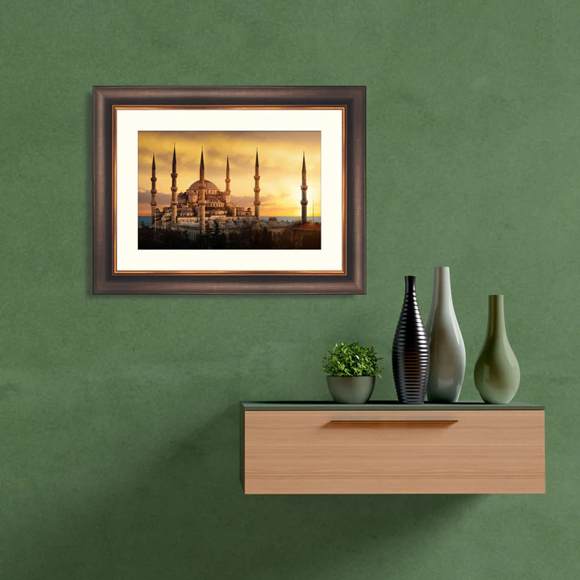The Blue Mosque in Istanbul, bathed in the golden hues of a setting sun, becomes a breathtaking vision of architectural grandeur. Its cascading domes and towering minarets seem to glow as the soft light dances across the intricate blue İznik tiles that give the mosque its name. The serene atmosphere is heightened by the evening call to prayer, blending harmoniously with the gentle rustle of the Bosphorus breeze. The surrounding gardens, with their vibrant flowers and fountains, create a tranquil contrast to the bustling city beyond. At sunset, the Blue Mosque embodies the timeless beauty and spiritual essence of Istanbul.